A research on gas-fired (gas turbine) power plants

**GAS-FIRED POWER PLANTS**

**INTRODUCTION**

A gas-fired power plant is a type of fossil fuel power station in which chemical energy stored in natural gas, which is mainly methane, is converted successively into: thermal energy, mechanical energy and, finally, electrical energy. Although they cannot exceed the Carnot cycle limit for conversion of heat energy into useful work the excess heat may be used in cogeneration plants to heat buildings, produce hot water, or to heat materials on an industrial scale.

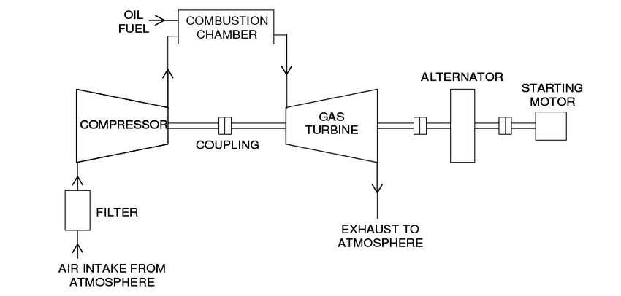

Gas Fired Power Plant

**WORKING PRINCIPLE**

Gas turbine engines derive their power from burning fuel in a combustion chamber and using the fast flowing combustion gases to drive a turbine in much the same way as the high pressure steam drives a steam turbine. A simple gas turbine is comprised of three main sections a compressor, a combustor, and a power turbine. The gas-turbine operates on the principle of the Brayton cycle, where compressed air is mixed with fuel, and burned under constant pressure conditions. The resulting hot gas is allowed to expand through a turbine to perform work.

**TYPES OF GAS FIRED POWER PLANTS**

Simple cycle gas turbine

Combined cc